BOOKENDS HOSPITALITY PVT. LTD.
Internal Operations — Regulatory Readiness Series

FSSAI Schedule 4 & FDCA Compliance Readiness Report

AIKO — Ambli, Ahmedabad, Gujarat

Outlet / Brand | AIKO
Location | Ambli, Ahmedabad, Gujarat
Business Category (presumed) | Restaurant
Report Type | Internal walk through dated 15 August 2026.
Inspection/Audit By | Vishal Patel
Report Prepared By | Vishal Patel

Ref | Priority | What the evidence shows
K19 ★ | Critical | A pest (cockroach) was photographed on the floor on the audit day, despite this checkpoint being scored 2. The pest-control certificate on file is addressed to a different business name and had already lapsed for over a  year.
K15 ★ | 1 evidence | Fitness certificates not available.

Ref | Checkpoint | Rating | Priority | Remark
S1 ★ | FSSAI licence displayed and valid; Food Safety Display Board put up | 4 | Compliant
Ref | Checkpoint | Rating | Priority | Remark
S2 | FSSAI licence number printed on menu | Non-Compliant | High | 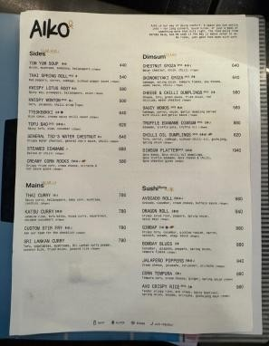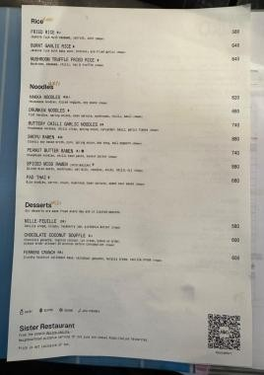

Ref | Checkpoint | Rating | Priority | Remark
S8 | Hand wash or sanitizer available for guests and staff | 2 | Compliant | —
S10 | Drinking water potable/filtered; dispenser and jug clean | 1 | Partial | 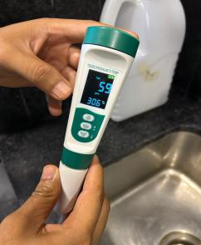
S13 | Restrooms clean and stocked; doors do not open directly into food area | 2 | Compliant | —
K18 | Hand wash stations stocked — soap, sanitizer, paper towel | 2 | Compliant | —
K20 | Drain traps in place, flowing and clean; no standing water | 2 | Compliant

Ref | Checkpoint | Rating | Priority | Remark
S11 | Table condiments/sachets within expiry date; containers clean | 2 | Compliant
K1 ★ | No expired or undated items anywhere on the premises | 0 | Major | 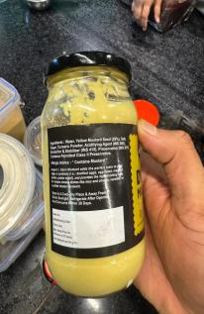  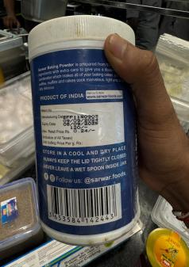  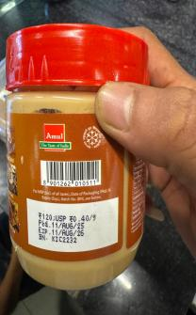  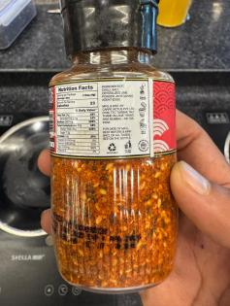  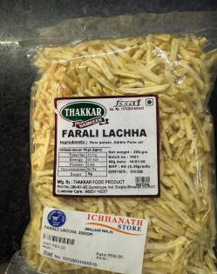  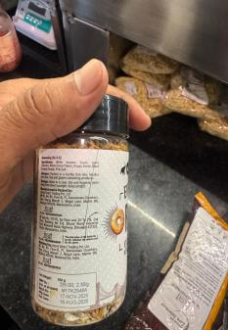

Ref | Checkpoint | Rating | Priority | Remark
K2 | Decanted containers labelled with name and date; FIFO followed | 0 | Major | 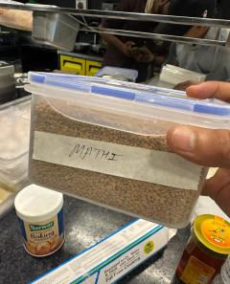  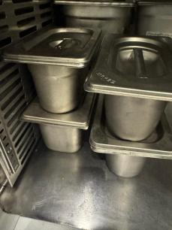
K4 ★ | Raw and cooked food completely segregated | 4 | Compliant | —
K5 ★ | Veg segregated in storage and prep | 4 | Compliant | —
K6 ★ | Chiller ≤ 5°C, freezer − 18°C; temperature log up to date | 4 | Compliant | —
K7 | Hot holding ≥ 60°C; cooking to a core temperature ≥ 75°C | 2 | Compliant | —
K8 | Thawing only under refrigeration — never at room temperature | 2 | Compliant | —
K12 | Frying oil within TPC limit; oil-change log up to date | 2 | Compliant
K14 | Only approved colours/additives used; declaration on file | 2 | Compliant

S3 | Tables, chairs and other guest-area surfaces clean and sanitized |  |  | 2 |  | Compliant
Ref | Checkpoint |  |  | Rating |  | Priority |  | Remark
S12 | Waste bin covered, foot-operated, not overflowing |  |  | 0 |  | Major |  | 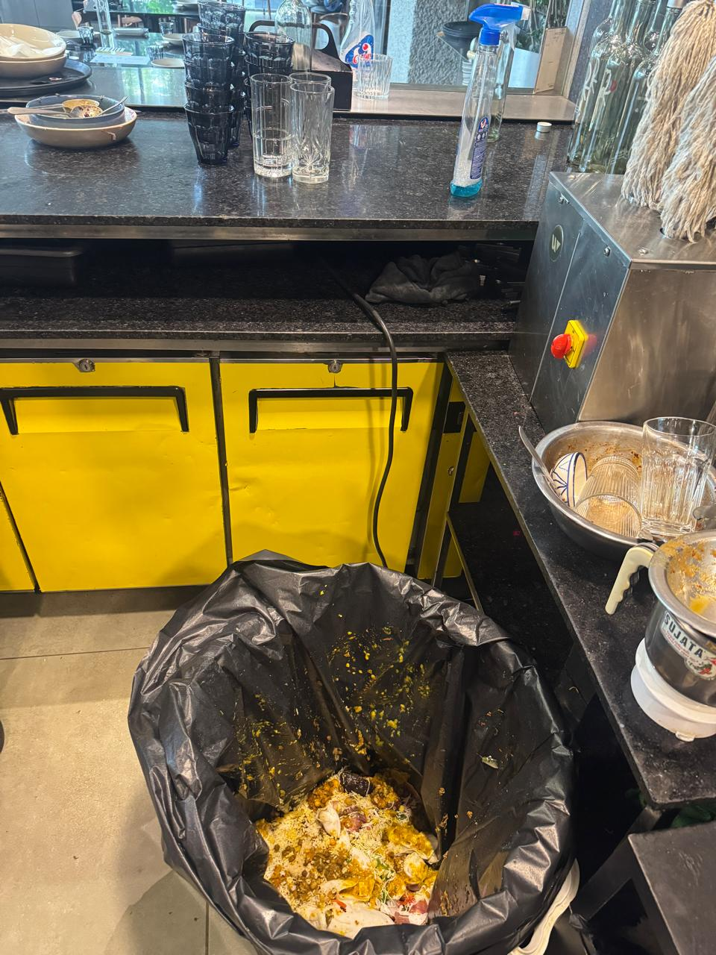
K9 |  | Chemicals labelled not mention and stored away from food | 0 |  | Major |  | 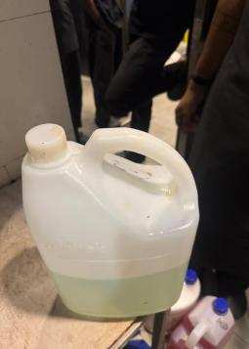  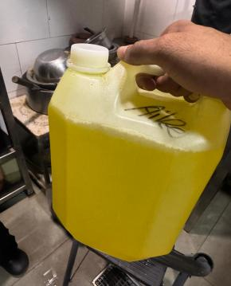
S14 | Pest barrier functional at entrance (air curtain / insect-o-cutor); no signs of pests in dining area | 0 | Major | No record
K19  ★ | No pest activity; pest-control service record up to date; stations mapped | 0 | Major | No record
Ref | Checkpoint | Rating | Priority | Remark
K21 | Waste segregated, bins covered, emptied daily | 1 | Minor
S4 | Floors, walls, ceiling clean — no cobwebs, seepage or flaking paint | 1 | Minor | 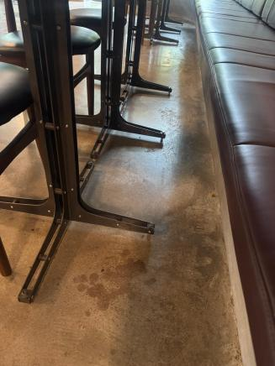
S5 | Counters and display units clean; displayed food covered and temperature-held. | 2 | Compliant | —
S9 | Crockery, cutlery and glassware clean, chip-free, stored covered. | 2 | Compliant | —

K3 | Storage 15 cm off the floor; no cartons or food on the floor. | 2 | Compliant | —
K10 | Dry store clean, ventilated, pest-free. | 2 | Compliant | —
K11 | Colour-coded boards / separate prep tools in use | 2 | Compliant | —
K13 | Food-contact surfaces and equipment clean — no rust, damage or wooden patches | 2 | Compliant | —
K22 | Exhaust and hoods degreased; ventilation adequate; lights protected | 2 | Compliant | —
K20 | Drain traps in place, flowing and clean; no standing water | 2 | Compliant
S6 | Service staff in clean uniform  — cap, trimmed nails, no jewellery | 0 | Major | 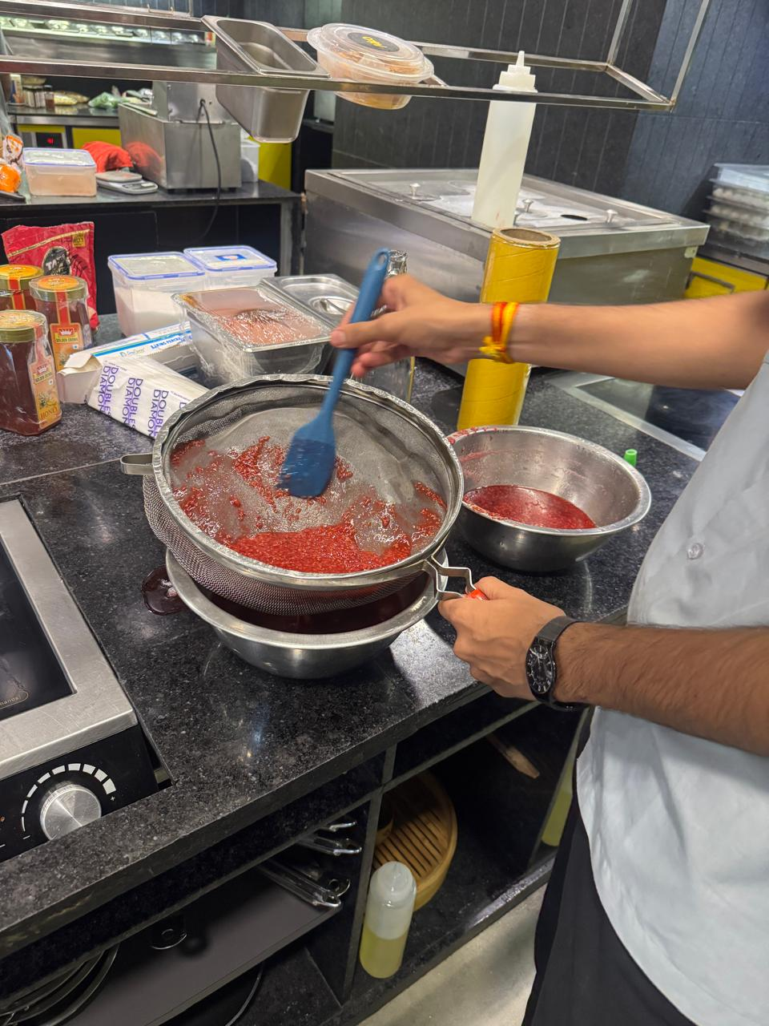
S7 | No unwell staff on duty; cuts/wounds covered with waterproof dressing | 2 | Compliant
K15 ★ | Medical fitness certificate up to date for every food handler | 0 | Major | Not available
Ref | Checkpoint | Rating | Priority | Remark
S15 | Veg mark and allergen information on menu, where applicable | 0 | Major

Ref | Checkpoint | Rating | Priority | Remark
K17 | Kitchen staff — cap, apron, trimmed nails, no jewellery; no smoking or paan | 0 | Major
K16 | FoSTaC-certified supervisor on roster; certificate available | 0 | Major | Not available
Ref | Checkpoint | Rating | Priority | Remark
K23 ★ | Water potability report valid  — tested within the last 6 months | 0 | Major | Team reports an informal daily check is done, but there is no documented report; the formal 6-monthly lab report has not been renewed. 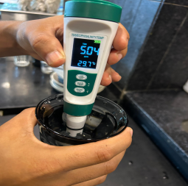
K24 | Deep-cleaning schedule up to date and followed; dispense log with temperature (CK checklist) | 2 | Compliant

Score & Grade

Section | Available marks | Obtained marks | %
A — Service Area | 32 | 20 | 62.5%
B — Kitchen Area | 62 | 37 | 59.7%
Total (Overall) | 94 | 57 | 60.6%

Conclusion
- Overall standing — 57/94 (60.6%), Needs Improvement; all 39 checkpoints were scored. 4 of the 8 ★ criticals are Non-Compliant (K1, K15, K19, K23), but S1 passes — the licence is displayed and valid — and K4, K5 and K6 hold, so segregation and the chiller and freezer controls are sound.
- The kitchen is the weaker half — 37/62 (59.7%) against the service area's 20/32 (62.5%). The guest-facing side largely holds — guest surfaces, crockery and display counters all pass — while the kitchen loses marks on stock control: expired or undated items (K1 ★, six photographs) and unlabelled decanted containers (K2), plus chemical storage (K9) and staff grooming (K17).
- Route to Satisfactory — the three documentation items (K15, K16, K23) carry 10 marks; closing them reaches 67/94 (71.3%), and clearing the pest pair (S14, K19) as well reaches 73/94 (77.7%). Two further items clear the 80% Satisfactory band.

